February 1, 2016 Newsletter

DOLPHIN INVITE EDITION!
Macomb Dolphins
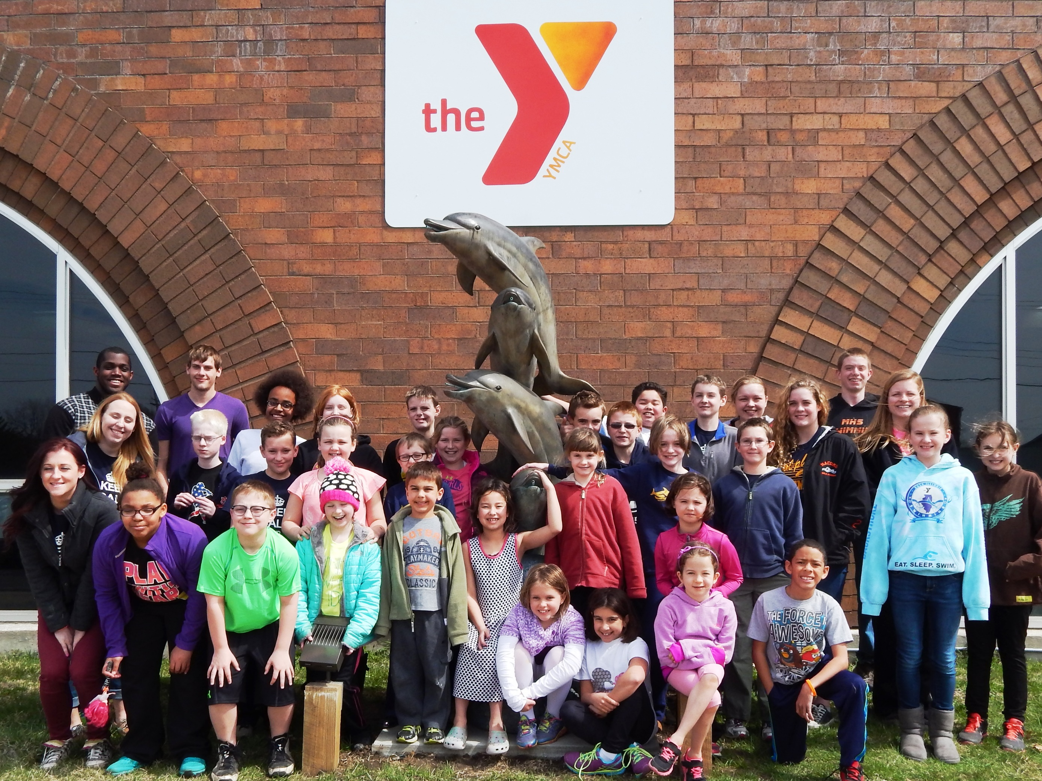

Upcoming Events

February 6
Knox Invite
(Galesburg)

February 13
DECY Valentines Open (Decatur)

February 20

Tri-meet with Warren and Knox (MACOMB)
Time Trials

February 27
Junior Districts
(Mattoon, IL)

March 4-6
District Meet
(Springfield)

March 18-20
State Championships
(St. John, IN)

Sponsor Spotlight

1110 E. Calhoun St., Macomb
309-837-1984

YMCA of McDonough County Swim Team

A Big Thank You from the PAC!
Our Annual Invite was a wonderful success! We received a number of positive comments from our team and other teams about the meet.
Thanks to each and every swimmer and swim family for their contributions to making our Dolphin Invitational Meet run so smoothly!

Information about Championship Meets
Our district and state championship meets are just around the corner. There are some changes from previous years regarding qualifying times for the district meet and disqualification times for Jr. Districts.
See the documents attached to the email accompanying this newsletter. Extra copies of these will be posted on the team bulletin board
Dolphin Championship Meet Sign Up - this is a sign up form for the team to let us know your intent to swim at the Jr. District, District, and State meets. Since we need to formally register all swimmers and set up potential relay teams, we need to know what you are planning to do. Please fill this out and turn it in to a PAC member or the YMCA front desk by February 9.

Qualifying/Disqualifying Standards Sheet - this sheet is a little hard to read, but essentially it tells you whether your child is eligible for each championship meet.
Jr. Districts - (12 and under swimmers only) is generally for swimmers who are younger or do not have district times. The time listed on the sheet is a disqualifying time - meaning that if your child's time in that event is faster than the listed time, they cannot swim that event at Jr. Districts.
District Meet - swimmers must meet "district time" to swim this year. It is more generous than in years past but they must now qualify to swim each event at districts.
You may note that there is gap between the Jr. District disqualifying time and the District qualifying time on the sheet. If your child qualifies for districts, they may choose to swim the event at Jr. Districts instead (but then they can't also swim that same event at district). Any swimmer who intends to go to the State Meet MUST "splash" at districts in at least one legal event in order to swim at the State Meet.
Illinois State Meet - you must qualify with "state time" in order to swim an event at this meet.
CONFUSED? You aren't alone.

PAC members will be on hand during the last 20 minutes of Wednesday's (February 3rd) and Thursday's (February 4th) practices (at both locations) to help parents decode the timing sheet and fill out the form. We will also try to have "best times" for each swimmer available as well so you can see where your swimmer is in each event.


Need Suits or Gear?
Have used items to sale?
There is space on our bulletin board to post regarding needed items or items available for sale.
As your kids outgrow their flippers, team suits, and practice suits, consider posting info on these items on our team bulletin board.

2015-16 PAC Members
Rich Musser, Pres.
ro-musser@wiu.edu
Tonya Hamer, V. Pres.
tonyahamer@gmail.com
Tawnya Adkins Covert, Sec.
adkcov@hotmail.com
Diana Kurasz, Treas.
kuraszd@hotmail.com
Mike Welch
rl-welch@wiu.edu
Erin Stegall
stegall555@comcast.net
Heather McIlvaine-Newsad
h-mcilvainenewsad@wiu.edu
Cindy Cavett
ccavett@macombymca.org

Other business:
- Yoga and Dry Land -Until the end of the season, there will be Optional extra dry land and yoga warm-ups starting at 5:45 at the High School for swimmers before practice. Kids need to bring a yoga mat or towel if they would like to participate.
- Interested in serving on the Parents Advisory Committee? We will be having elections at the end of the regular season. Contact Rich to learn more.

